Jenkins Task - 03

Task 1
Create one Jenkins job using the below code and create three stages:
- stage1: Git clone to download the source code.
- stage2: Sonarqube Integration to check the quality of code.
- stage3: Slack Integration to send the alerts to slack.
URL: https://github.com/betawins/VProfile-1.git
Objective
To create a Jenkins job with three stages:
- Git clone the source code
- Perform code quality analysis using SonarQube
- Send build and quality status notifications to Slack

Prerequisites
- AWS EC2 instance (Amazon Linux / RHEL)
- Jenkins installed and running
- Java (OpenJDK 11 or 17)
- SonarQube Server
- MySQL / PostgreSQL database
- Slack Workspace & Slack Jenkins Plugin
- GitHub public repository access

Step-by-Step Implementation

Stage 1: Jenkins Setup and Git Clone
- Launch an EC2 instance and connect Jenkins-Master instance.
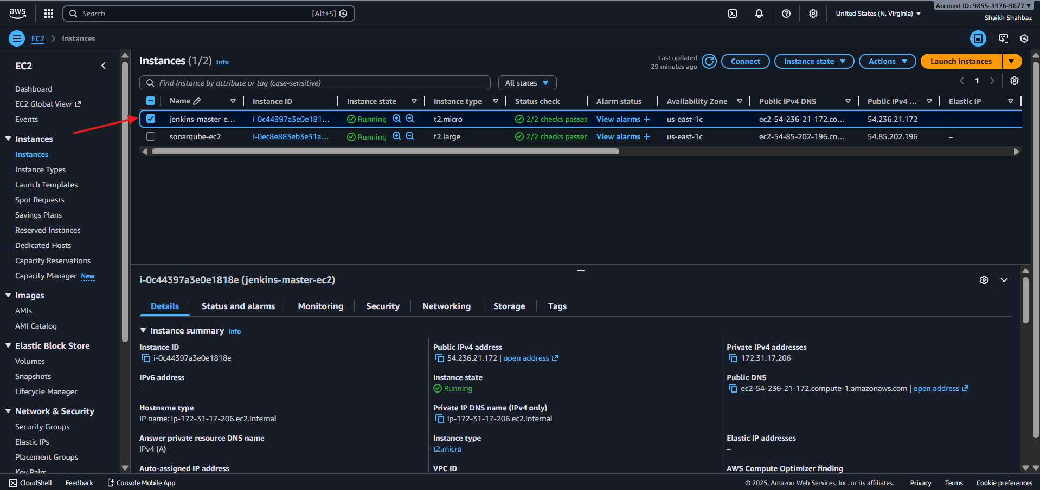
- Install Java:
sudo yum install java-17-openjdk -y
Install Jenkins and start the service:
sudo systemctl start jenkins
sudo systemctl enable jenkins
sudo systemctl status jenkins
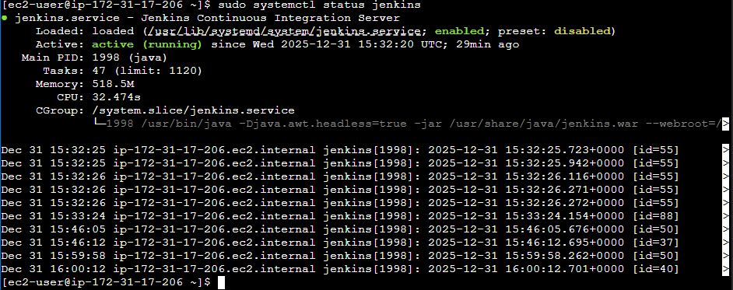
- Access Jenkins in browser:
http://<Jenkins-Public-IP>:8081
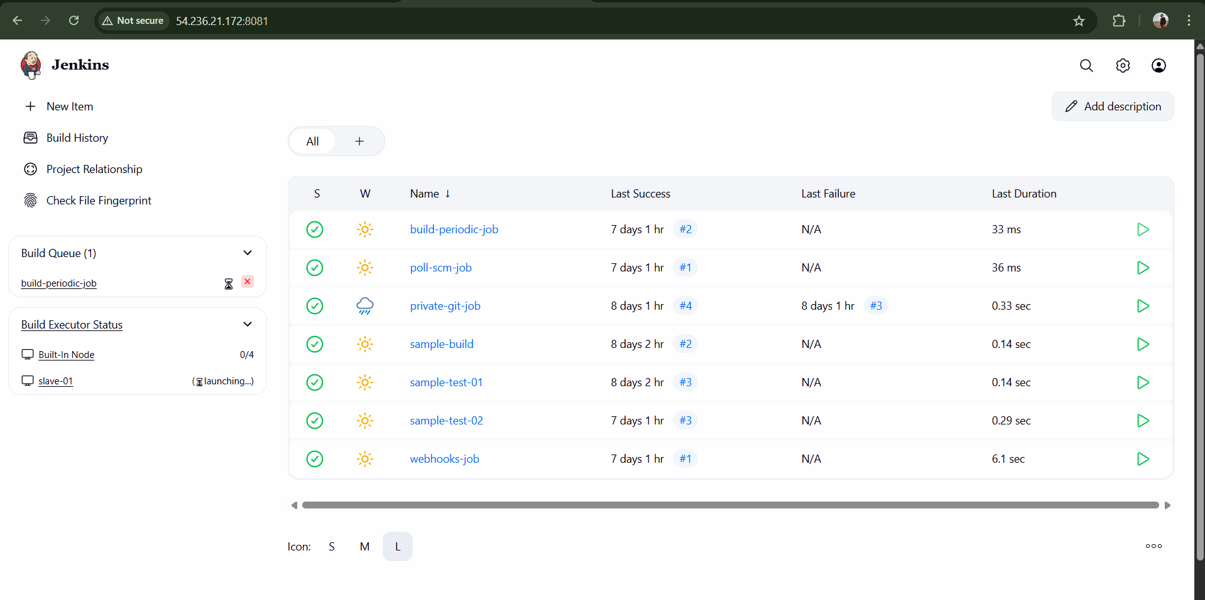
- Create a New Item → Freestyle Project.
- Under Source Code Management, select Git.
Enter repository URL:
https://github.com/betawins/VProfile-1.git
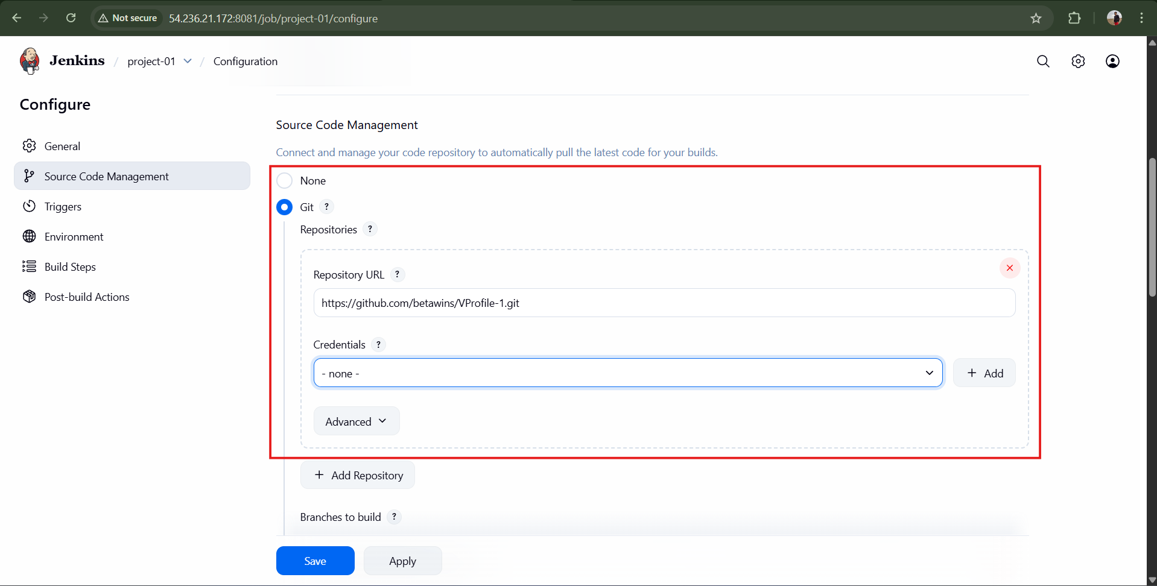
Save and click Build Now.
Result: Source code is cloned successfully.
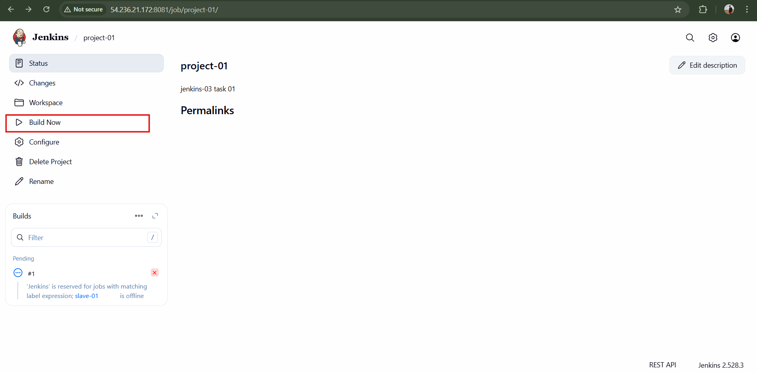

Stage 2: SonarQube Installation and Integration
- Launch a new EC2 instance (20 GB storage).
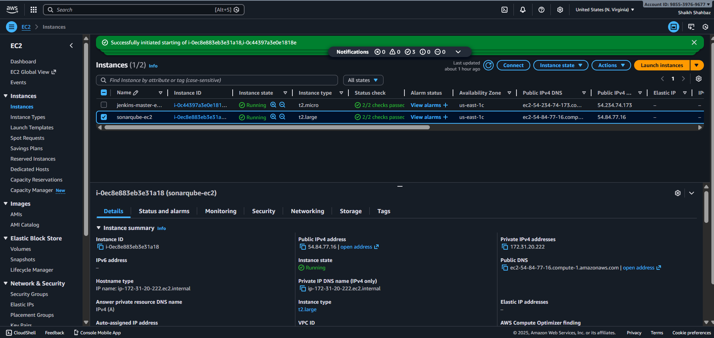
- Install Java:
- sudo yum install java-17-amazon-corretto -y
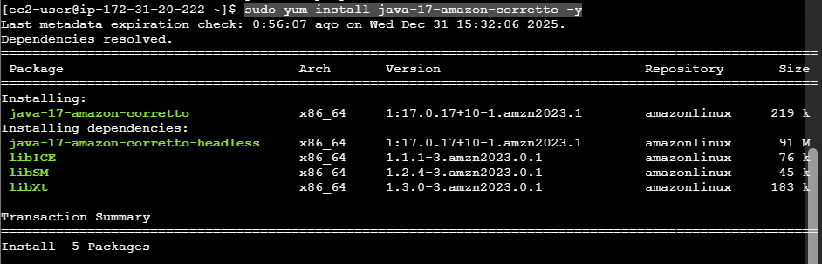
- Install database (PostgreSQL):
sudo yum install postgresql15-server postgresql15 -y
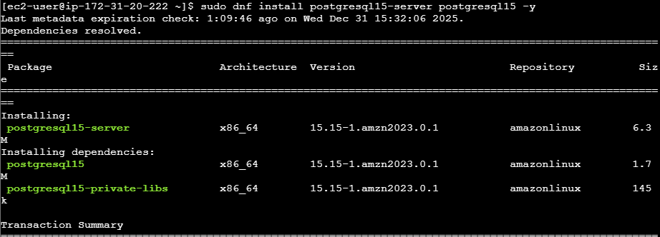
sudo postgresql-setup --initdb
sudo systemctl enable postgresql
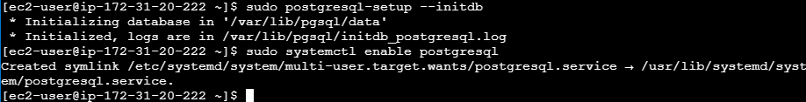
sudo systemctl start postgresql
sudo systemctl status postgresql
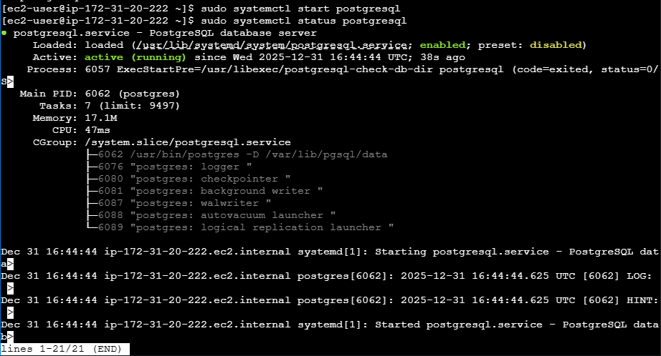
- Create SonarQube database and user.
sudo -u postgres psql
CREATE DATABASE sonarqube;
CREATE USER sonar WITH ENCRYPTED PASSWORD ‘sonar123’;
GRANT ALL PRIVILLAGES ON DATABASE sonarqube TO sonar;
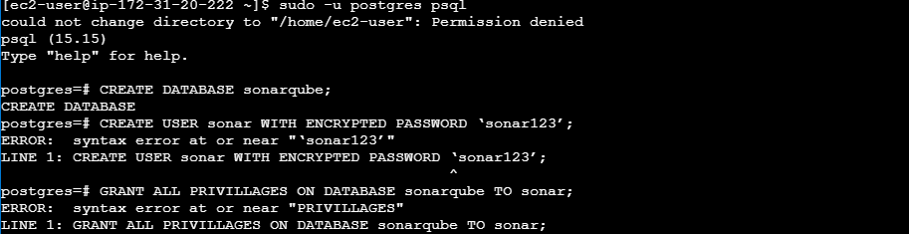
\list
\q
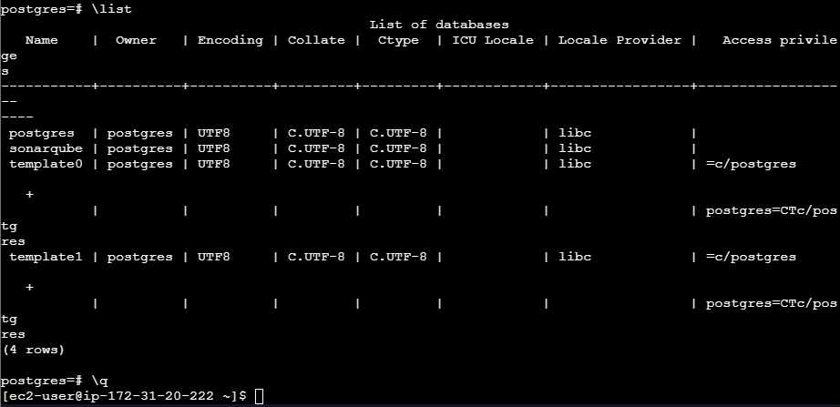
- Download and unzip SonarQube:
cd /opt
sudo wget https://binaries.sonarsource.com/Distribution/sonarqube/sonarqube-9.9.1.69595.zip
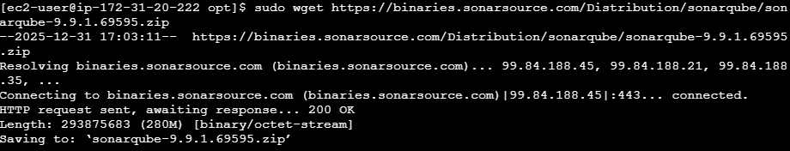
sudo unzip sonarqube-9.9.1.69595.zip
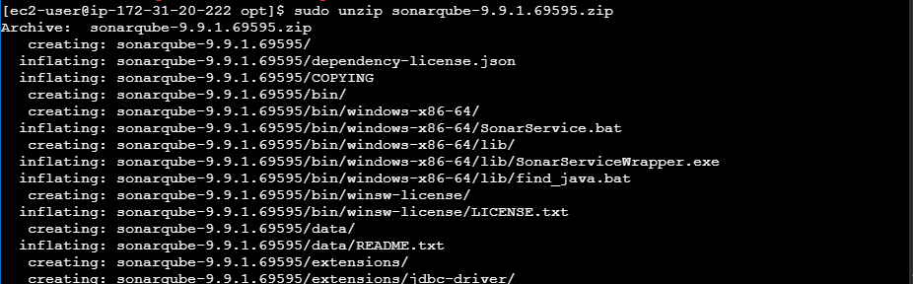
sudo mv sonarqube-9.9.1.69595 sonarqube
- Configure database details in:
Edit postgresql.conf
sudo vi /var/lib/pgsql/data/postgresql.conf
Find and modify the listen line to allow external and local connections:
listen_addresses = '*'
save and exit
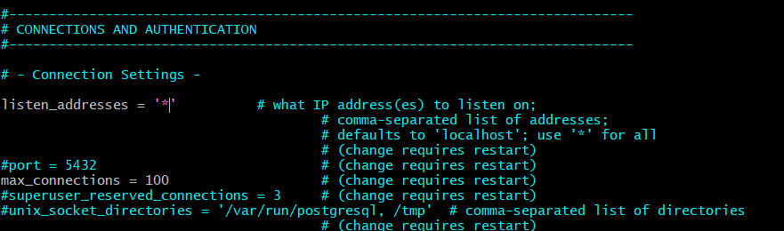
Edit pg_hba.cong
sudo vi /var/lib/pgsql/data/pg_hba.conf
Add these lines at the bottom to allow SonarQube to connect:
# Allow SonarQube access
host all all 0.0.0.0/0 md5
host all all 127.0.0.1/32 md5
Save & exit
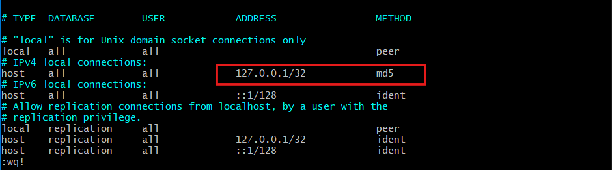
Restart PostgreSQL
sudo systemctl restart postgresql
sudo systemctl status postgresql
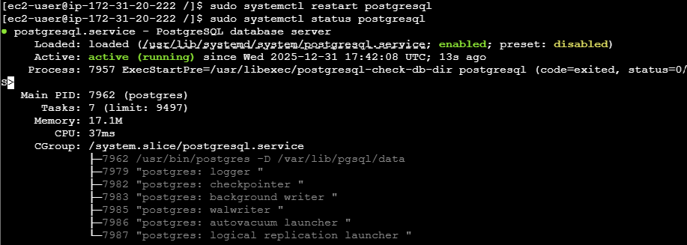
- Start SonarQube:
cd opt/sonarqube/conf
Edit below changes:
vi sonar.properties
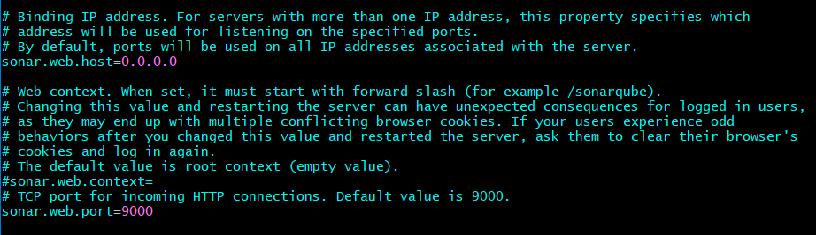
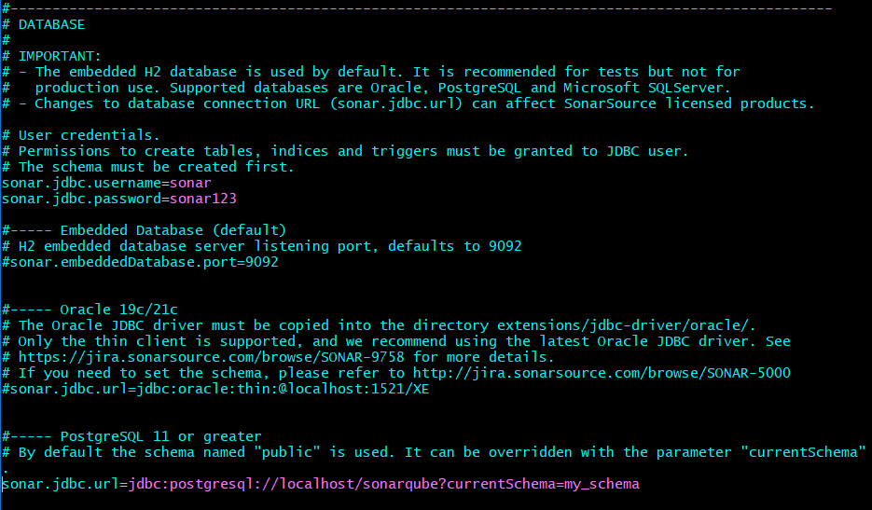
Save and exit

sudo /opt/sonarqube/bin/linux-x86-64/sonar.sh start
Create a SonarQube user
sudo useradd sonar
sudo passwd sonar123
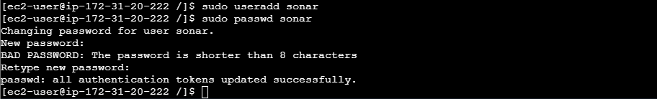
Give permissions to the SonarQube folder:
sudo chown -R sonar:sonar /opt/sonarqube
Switch to the sonar user
sudo su – sonar
Start SonarQube properly
/opt/sonarqube/bin/linux-x86-64/sonar.sh start
/opt/sonarqube/bin/linux-x86-64/sonar.sh status
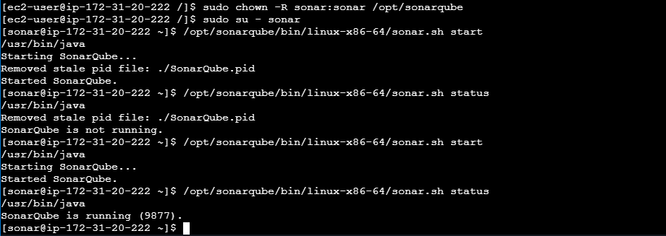
- Access SonarQube:
http://<SonarQube-Public-IP>:9000
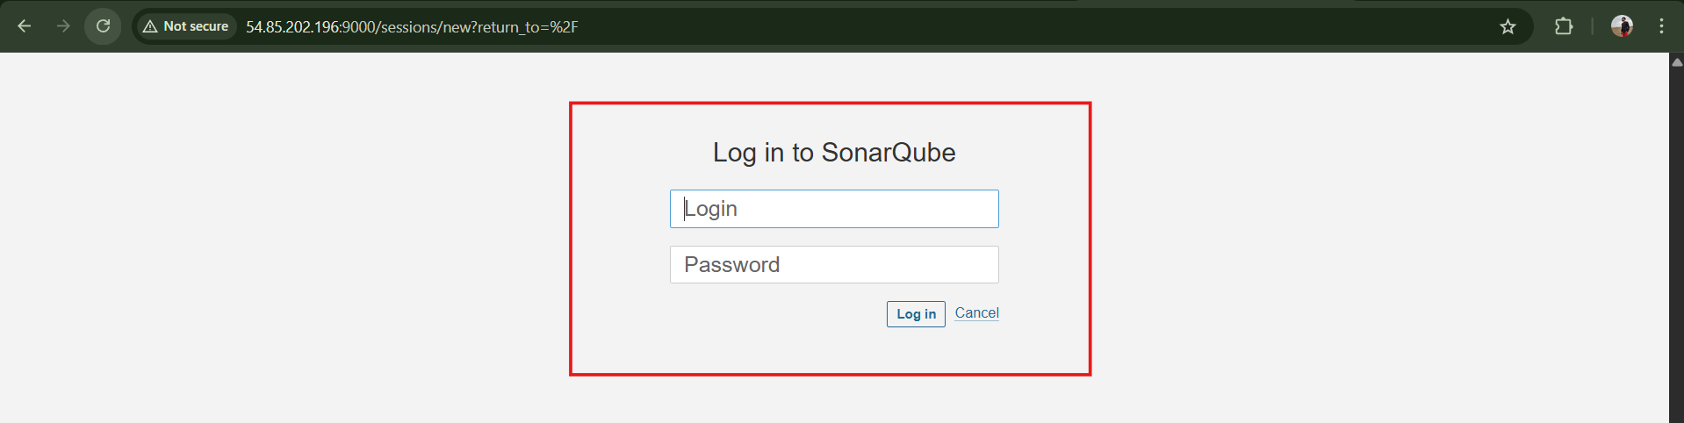
Login:admin
Password:avengers123
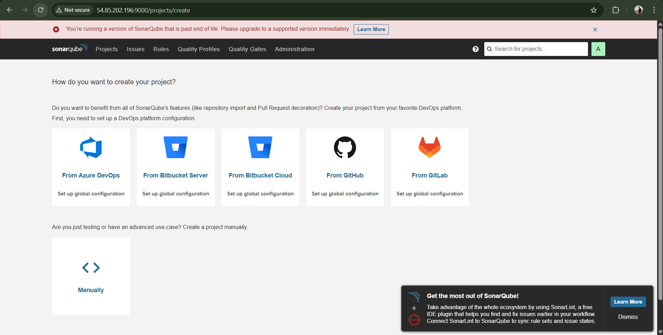
- Login (admin/admin) → Generate Sonar Token.
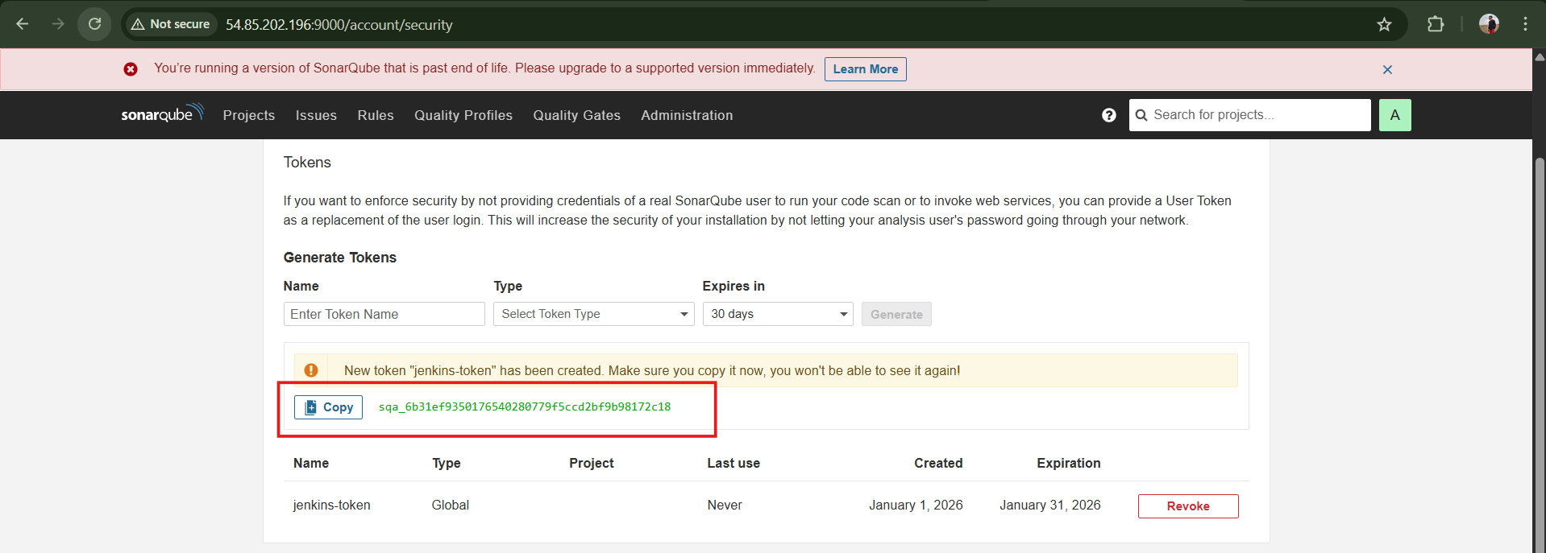
In Jenkins:
  - Install SonarQube Scanner Plugin
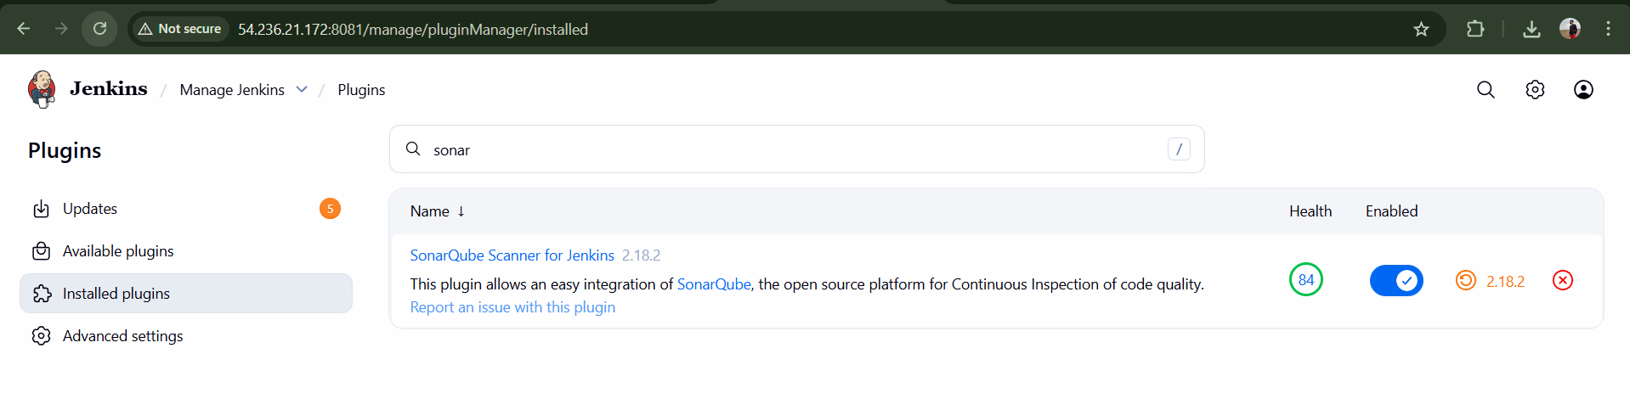

Configure SonarQube server under Manage Jenkins → System

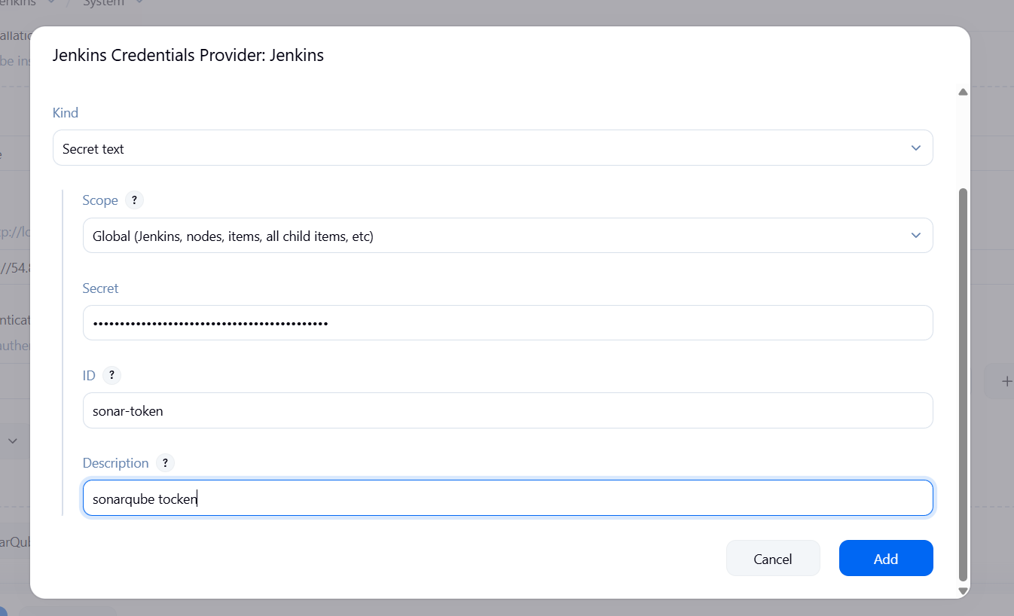
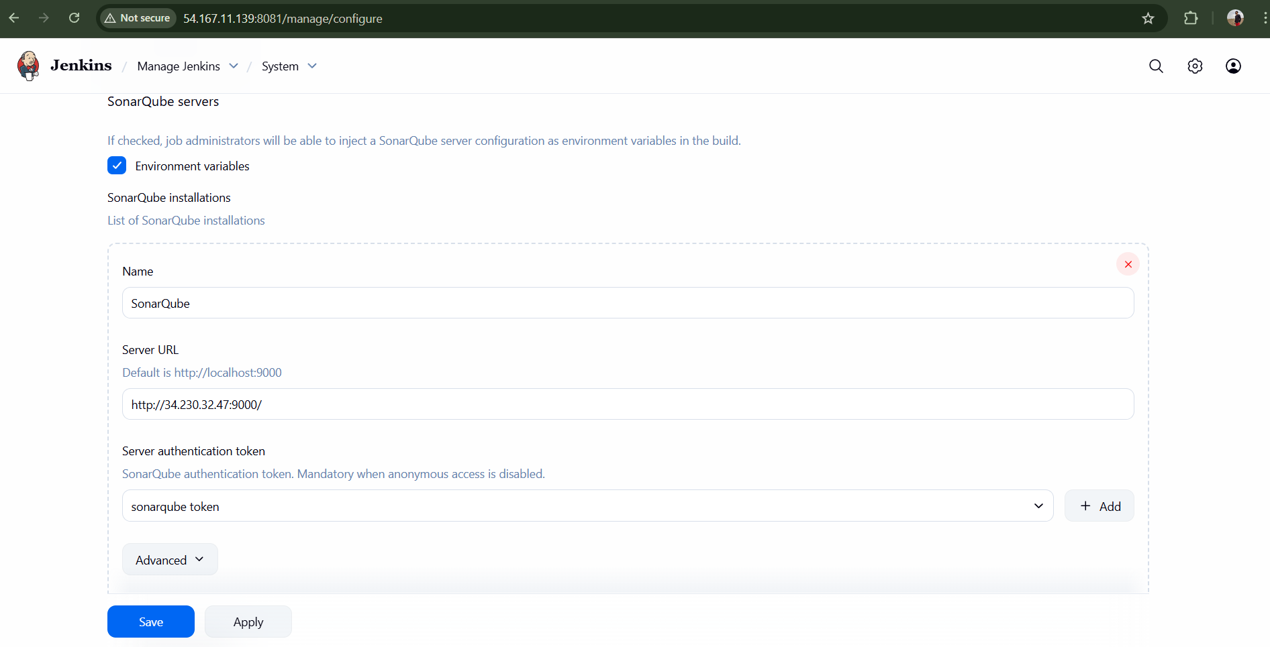
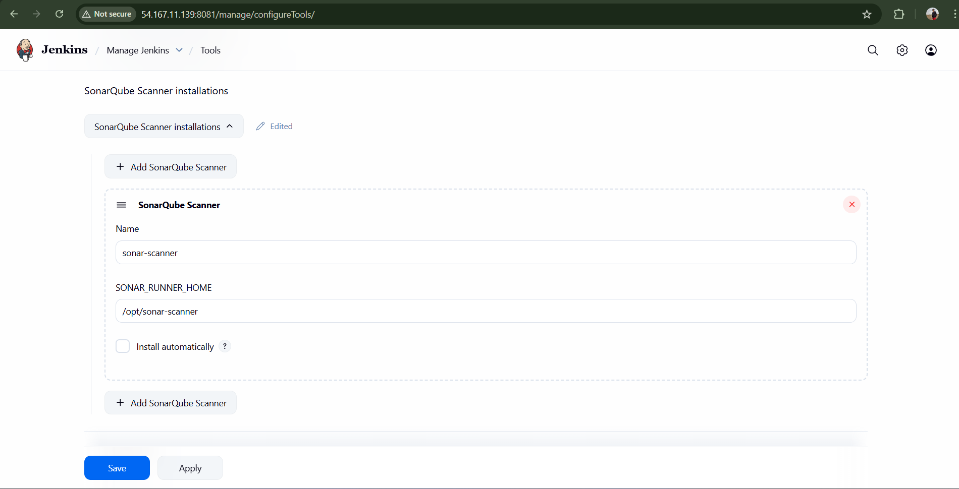

- Add SonarQube analysis step in Jenkins job and build.
We need to add this exactly copy and paste the below code
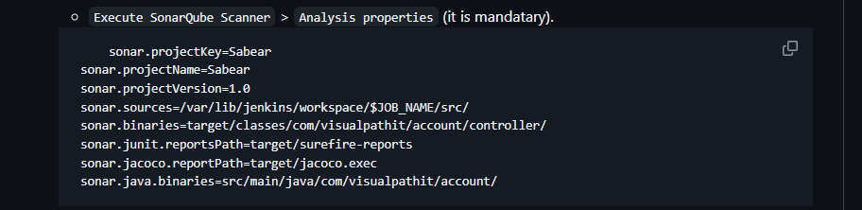
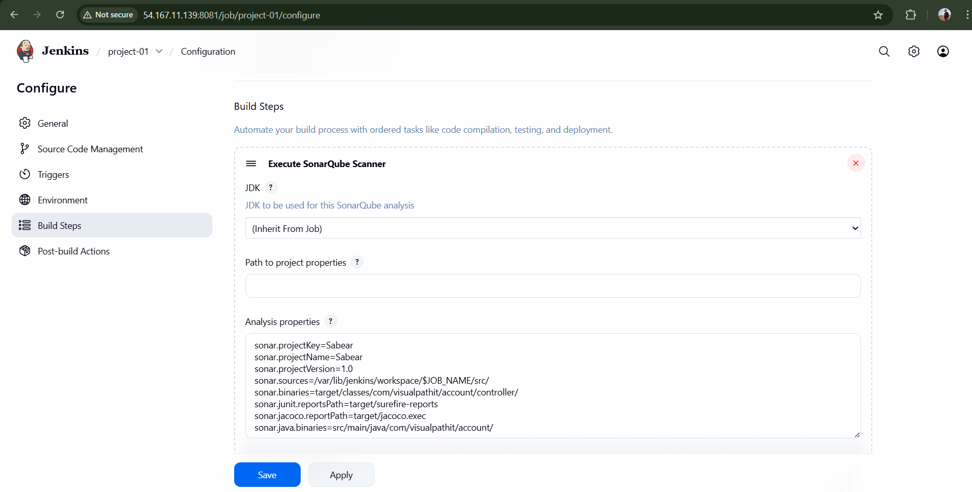
Result: Code quality analysis completed successfully.
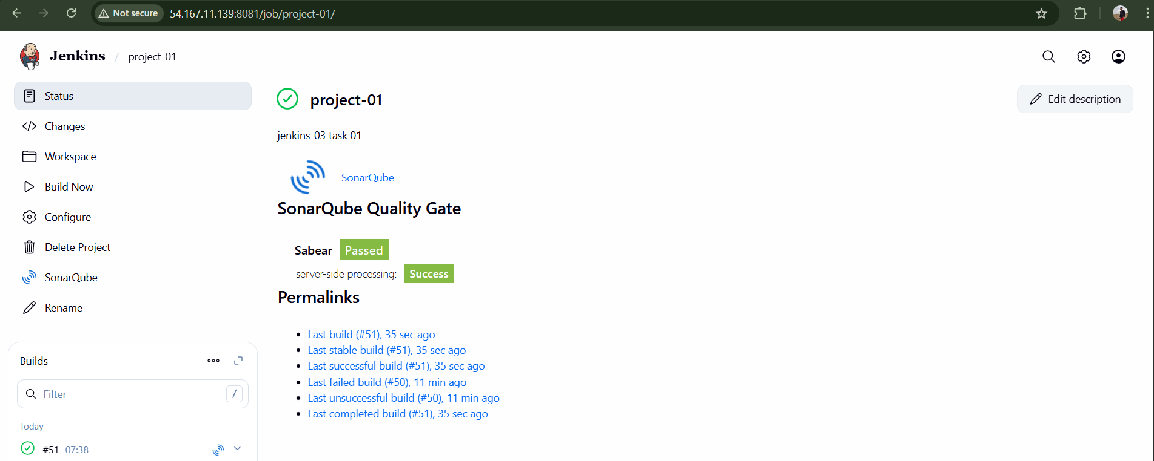

Stage 3: Slack Integration
- Install Slack Notification Plugin in Jenkins.
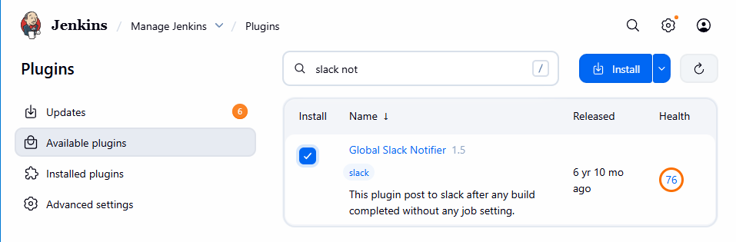
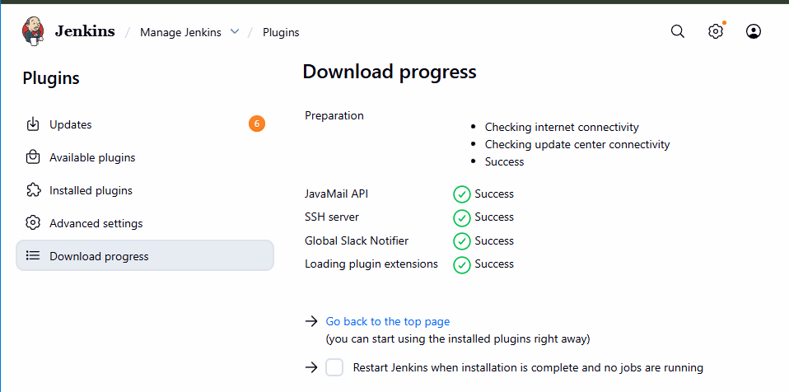
- In Slack Workspace:
  - Go to Apps → Jenkins CI Configure Add to slack
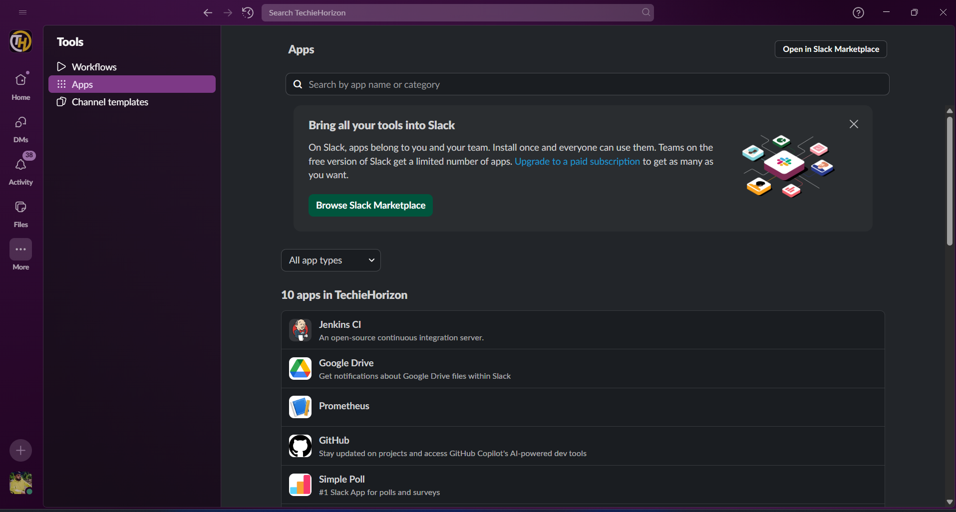
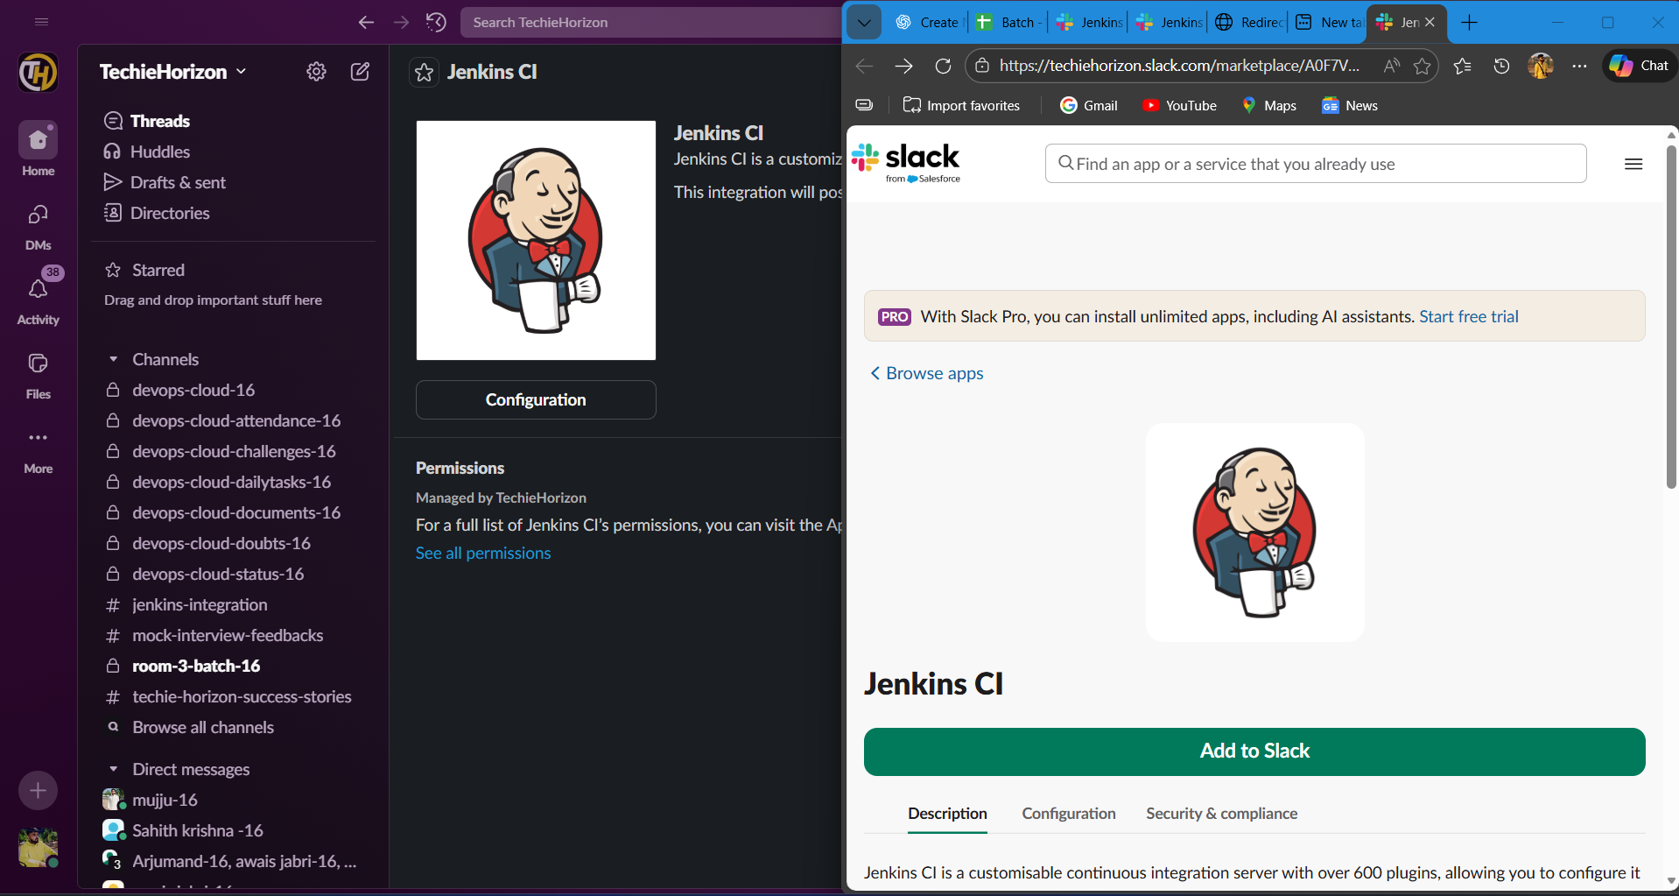
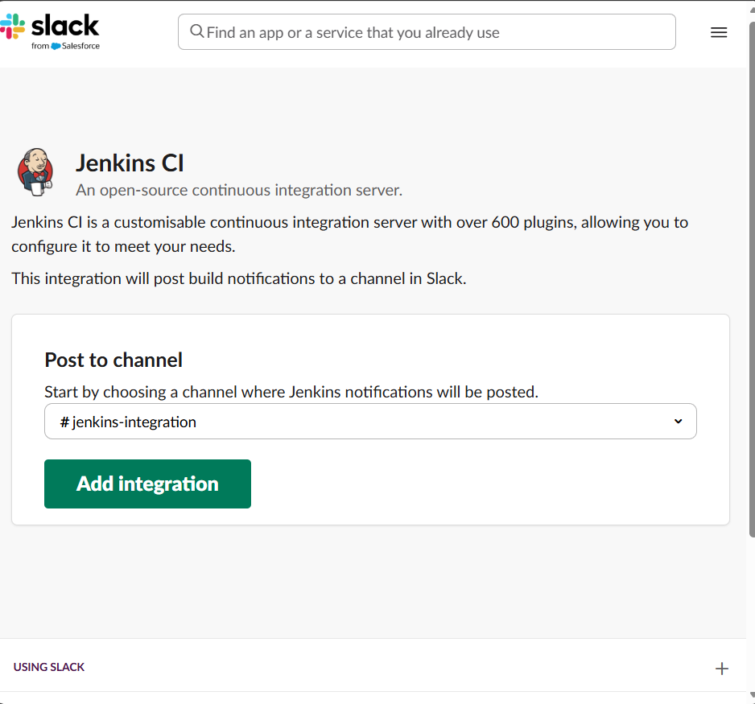

  - Generate Slack token

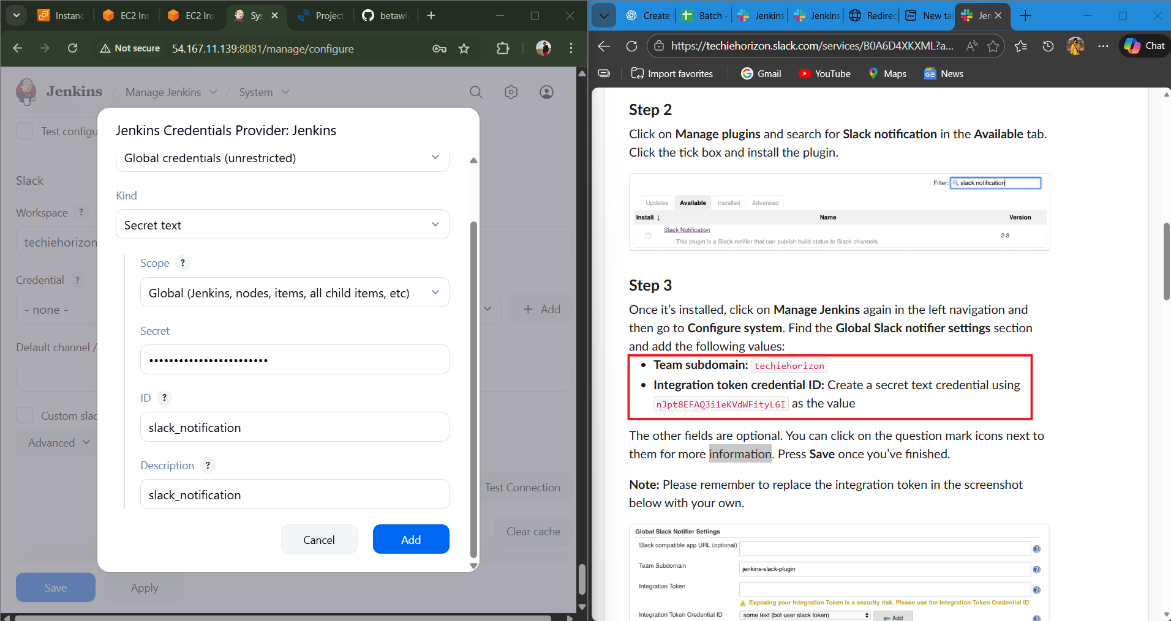

- Configure Slack under Jenkins system settings.
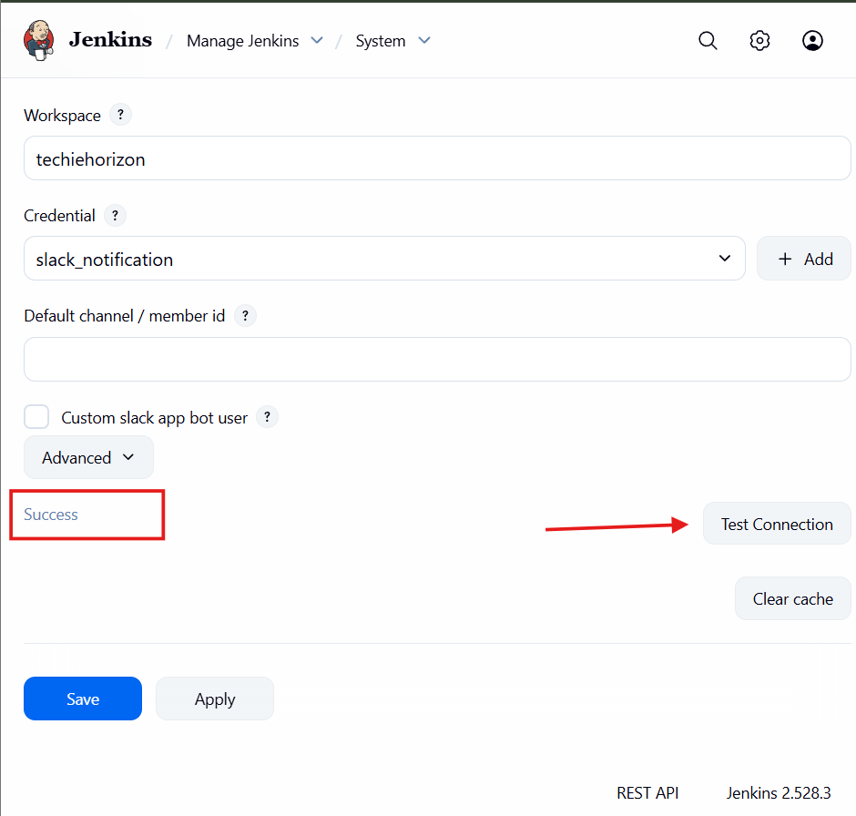

- Add Slack notifications in Jenkins job configuration.
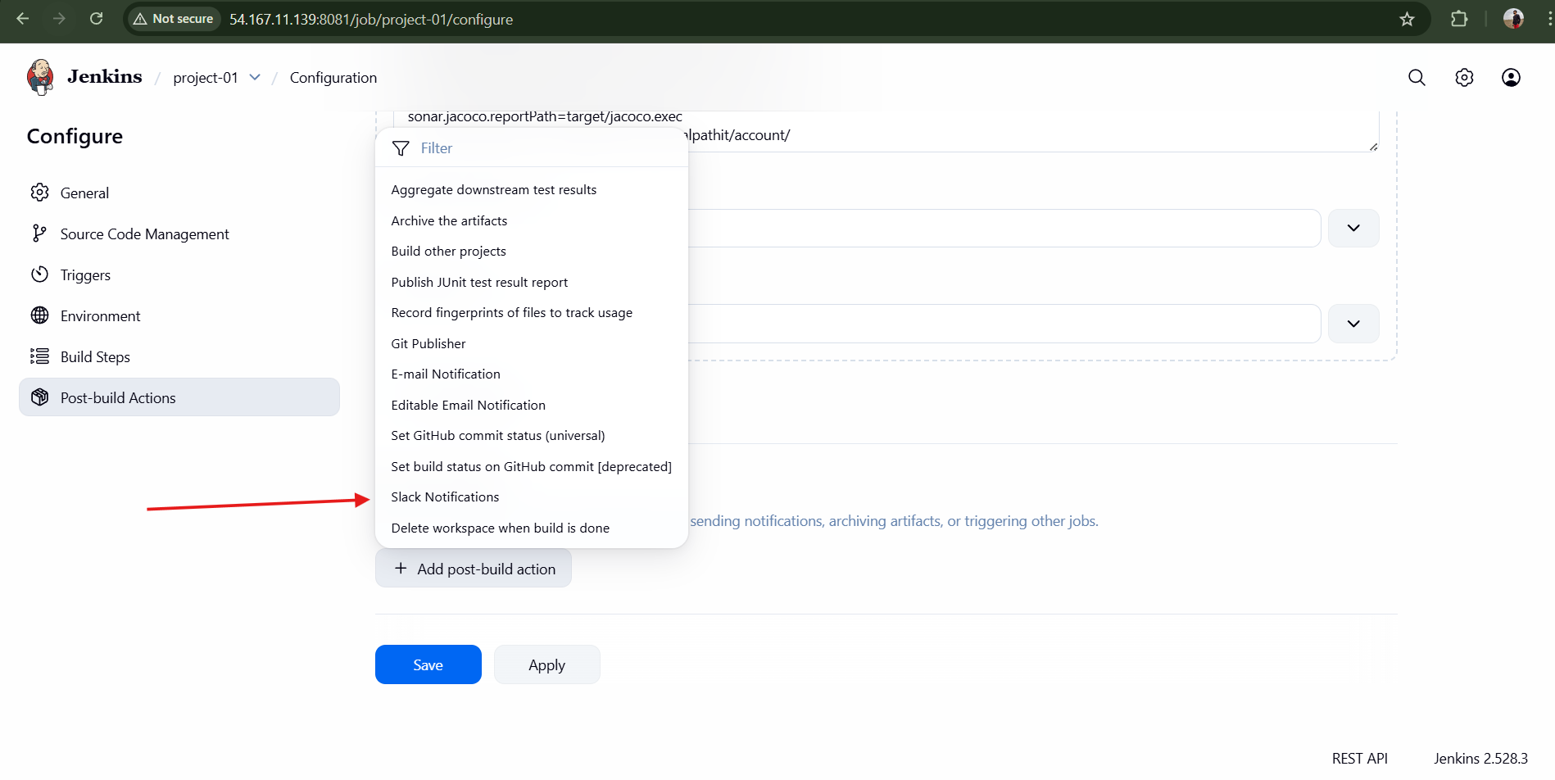
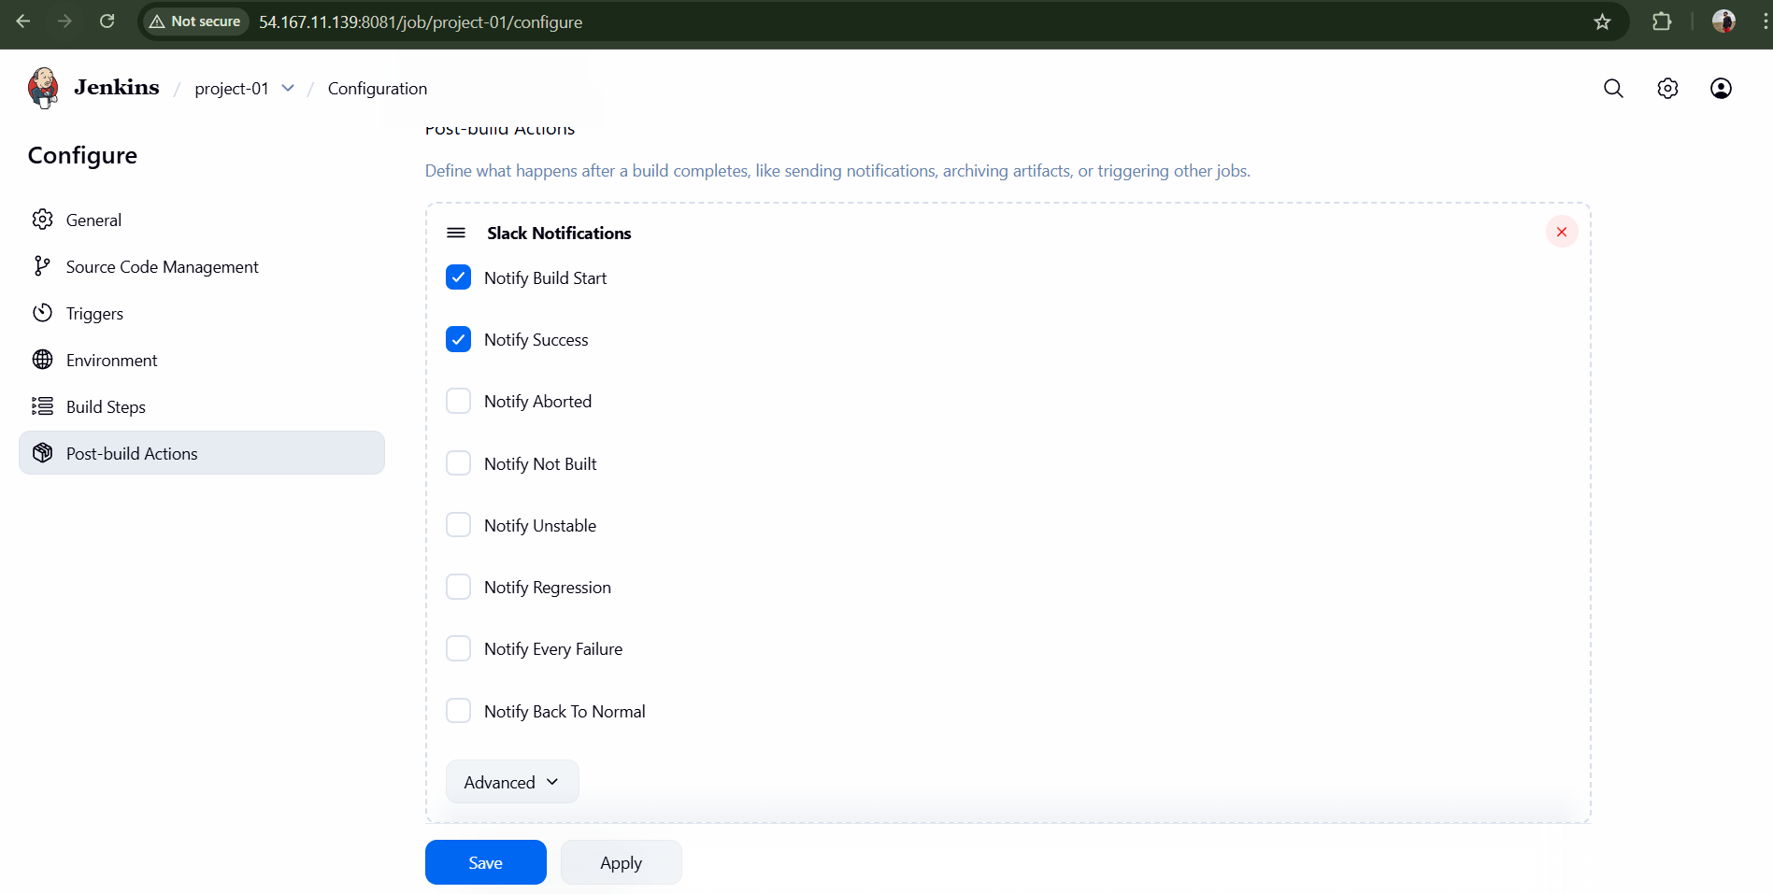

- Trigger Build Now.
Result: Slack receives build and SonarQube alerts.
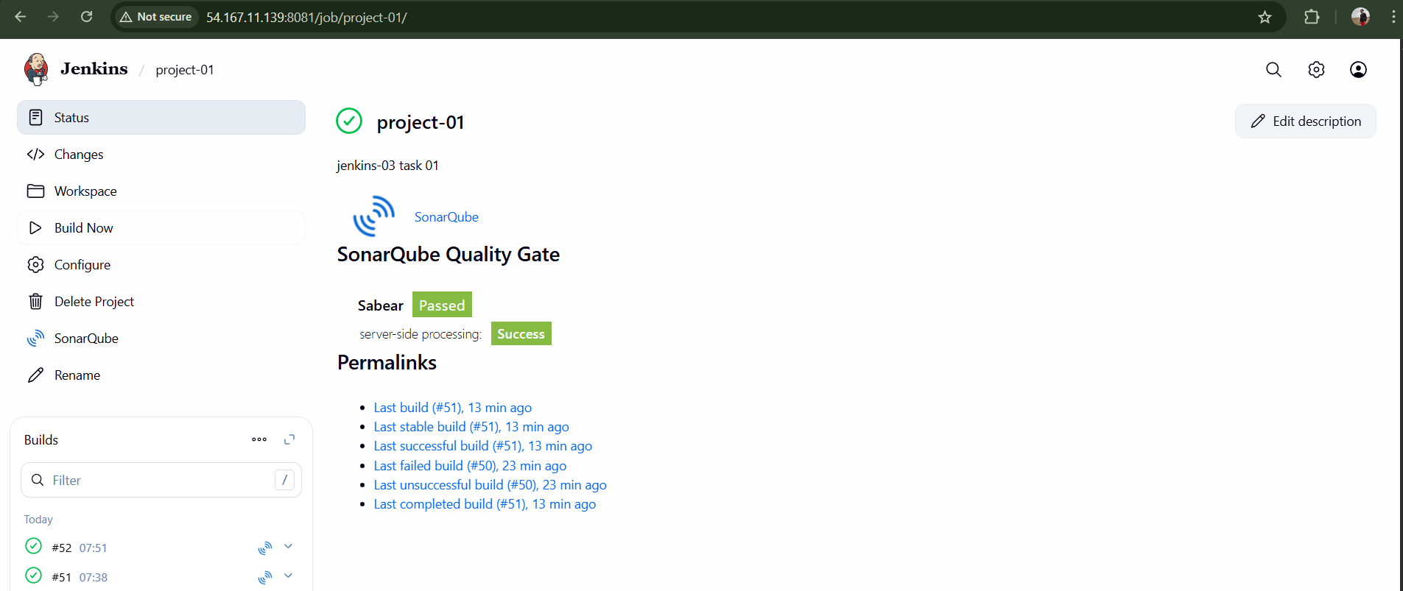
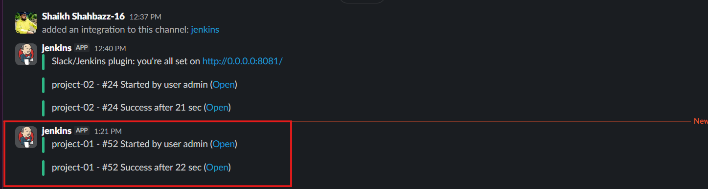
Conclusion
Successfully created a Jenkins job with Git clone, SonarQube code analysis, and Slack notifications for the VProfile application.

Task 2
Create one Jenkins job using the below code and create three stages:
- stage1: Git clone to download the source code.
- stage2: Sonarqube Integration to check the quality of code.
- stage3: Slack Integration to send the alerts to slack.
URL: https://github.com/betawins/hiring-app.git

Objective
To build a Jenkins pipeline with three stages using Docker-based SonarQube:
- Git clone
- Code quality analysis
- Slack notification

Prerequisites
- AWS EC2 instance
- Jenkins installed
- Docker installed
- SonarQube Docker Image
- Slack Workspace
- GitHub public repository

Step-by-Step Implementation

Stage 1: Git Clone via Jenkins
- Login to Jenkins server.
Create a Freestyle Project.
- Configure Git SCM with repository:
https://github.com/betawins/hiring-app.git
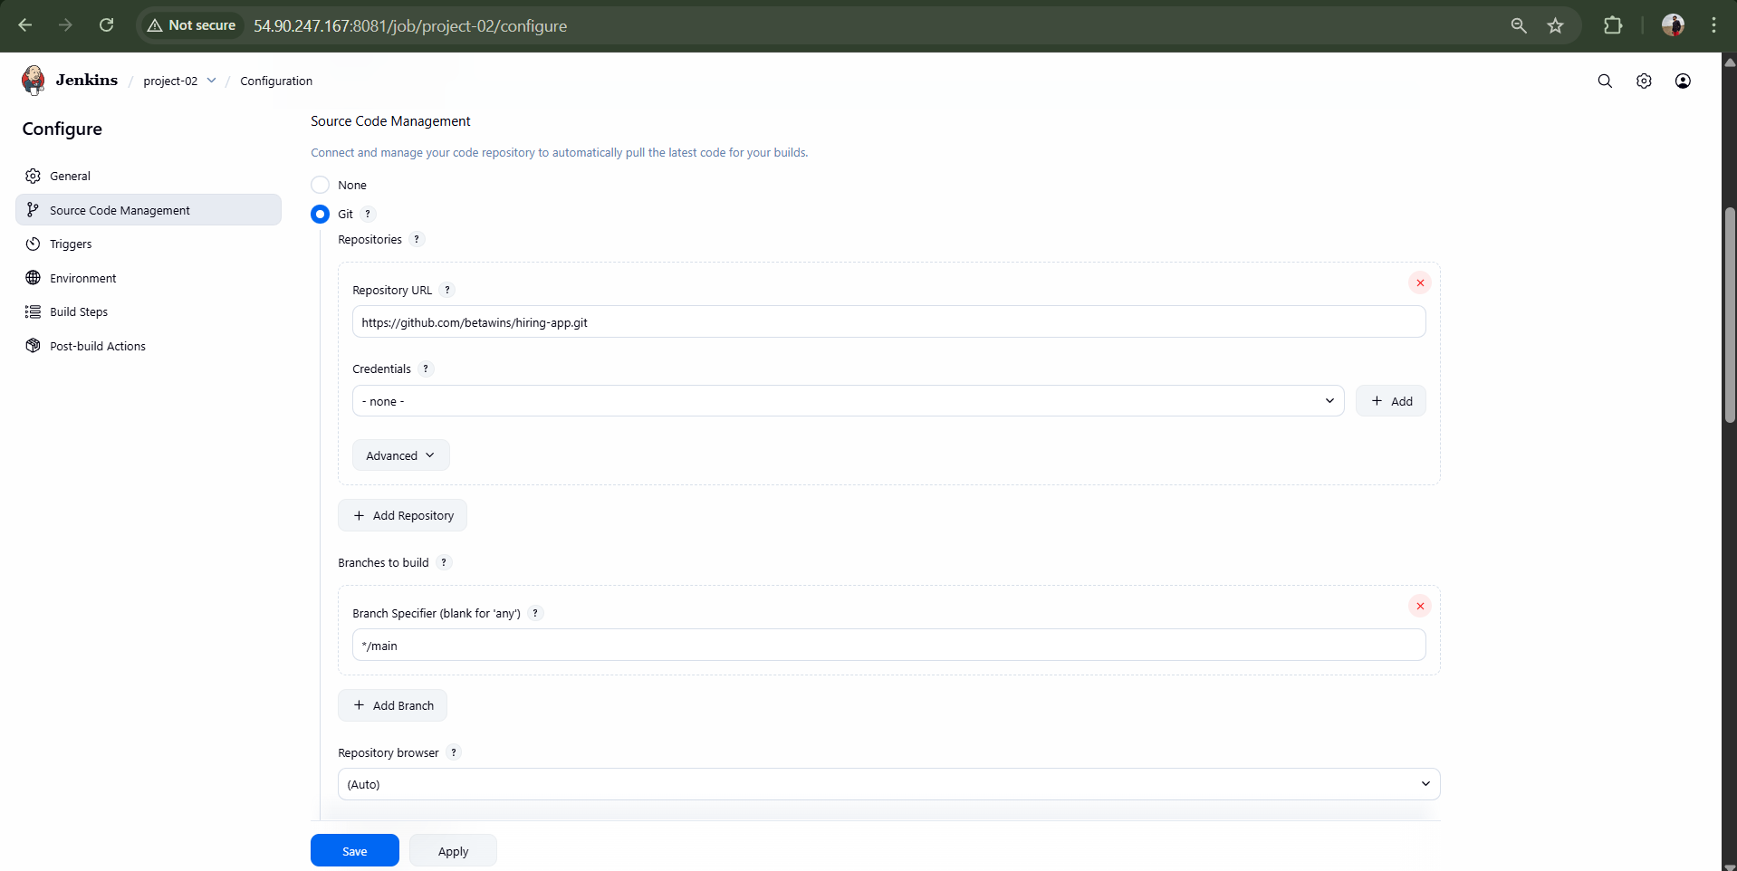
- Save and click Build Now.
Result: Repository cloned successfully.
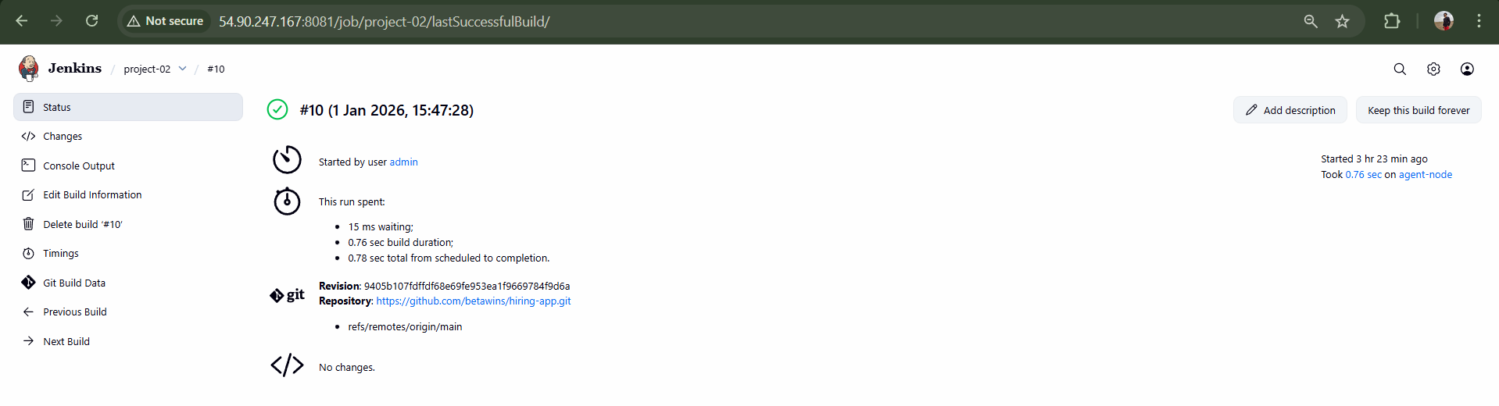
Stage 2: SonarQube Using Docker
- Launch a new EC2 instance.
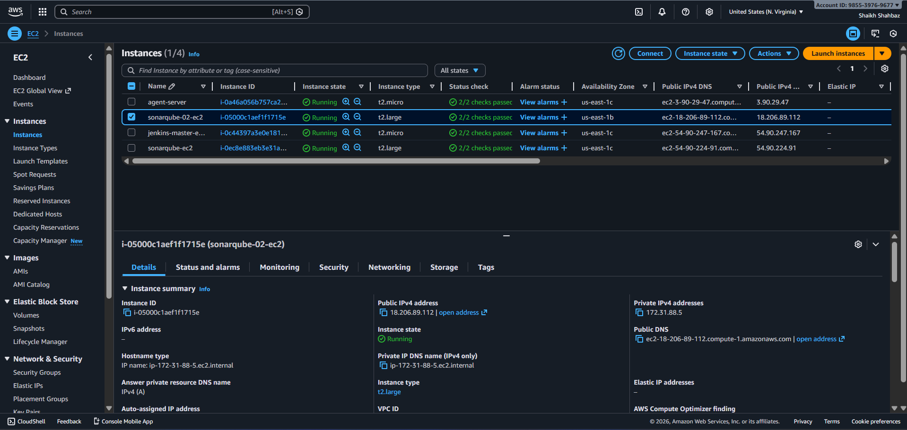
- Install Docker:
sudo yum install docker -y
sudo systemctl start docker
sudo systemctl enable docker
sudo systemctl status docker
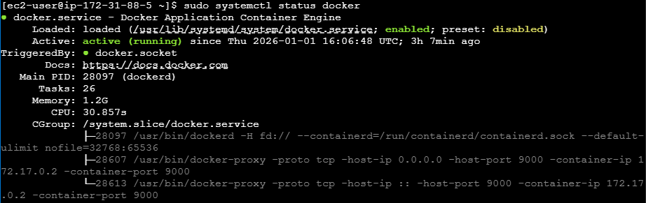
- Pull SonarQube image:
sudo docker pull sonarqube
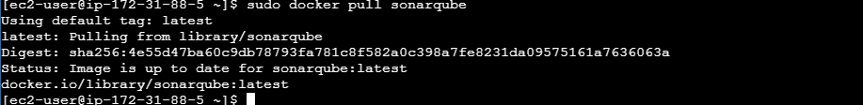
- Run SonarQube container:
sudo docker run -d -p 9000:9000 sonarqube

- Access SonarQube:
http://<Public-IP>:9000
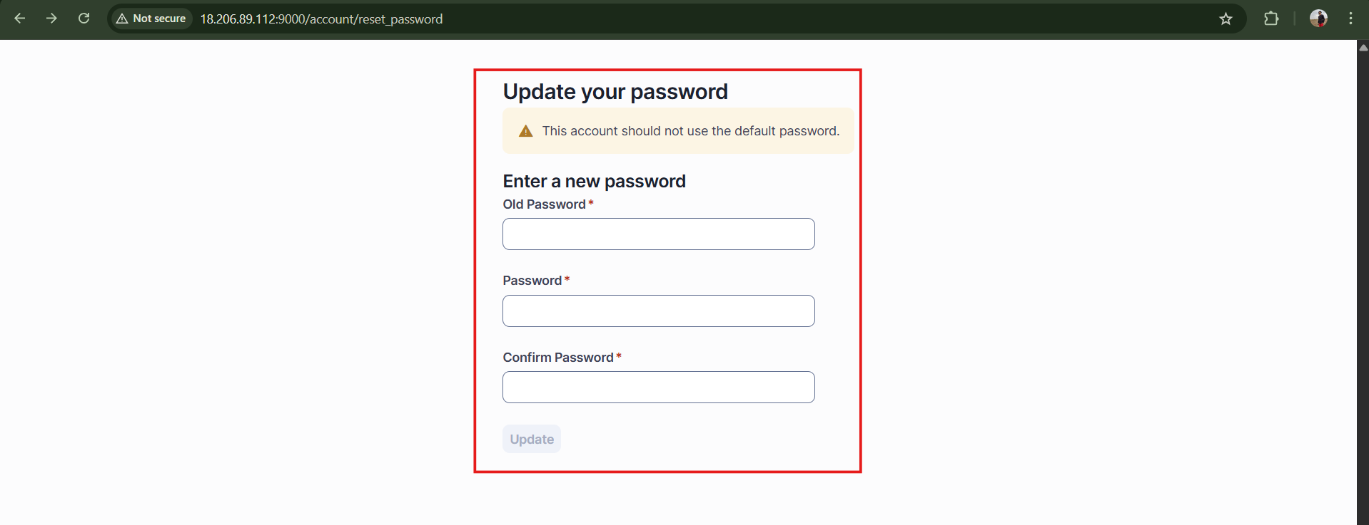
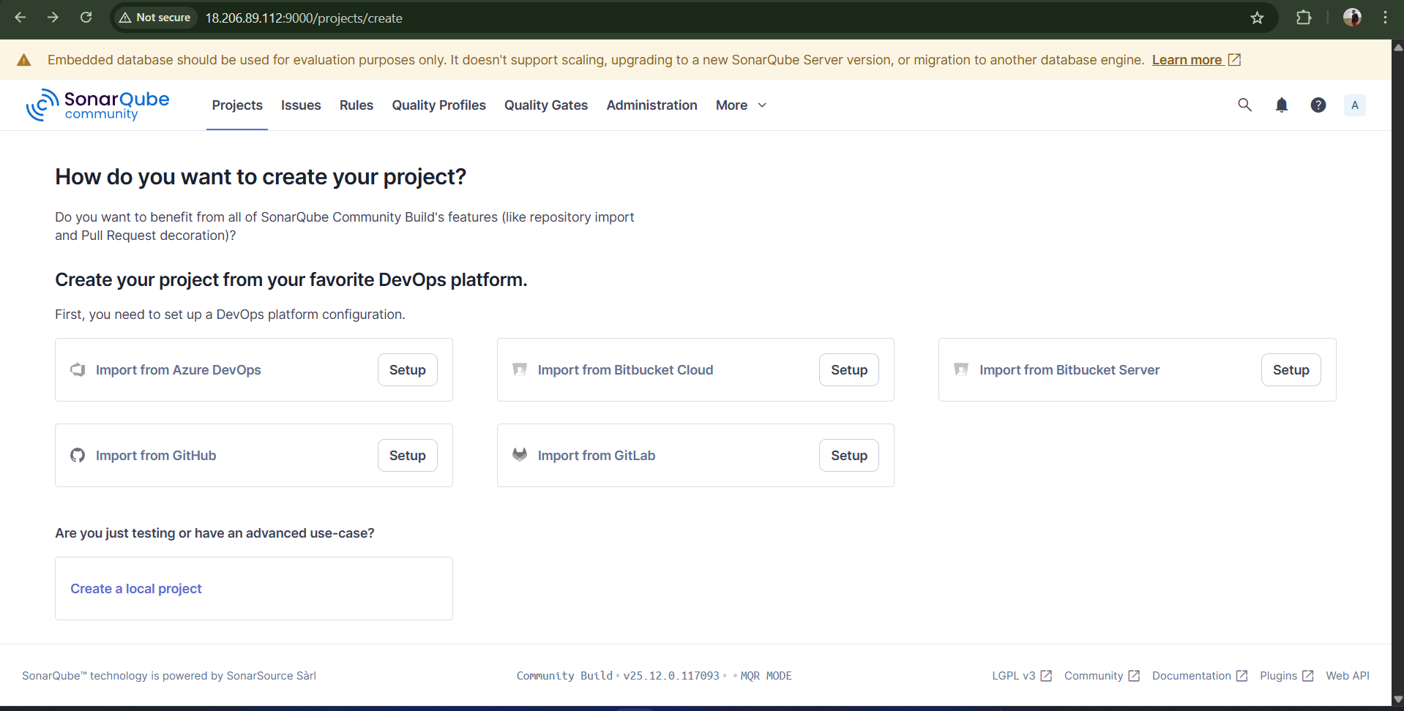
- Generate SonarQube token.
Goto sonarqube my account security tab Generate tokens
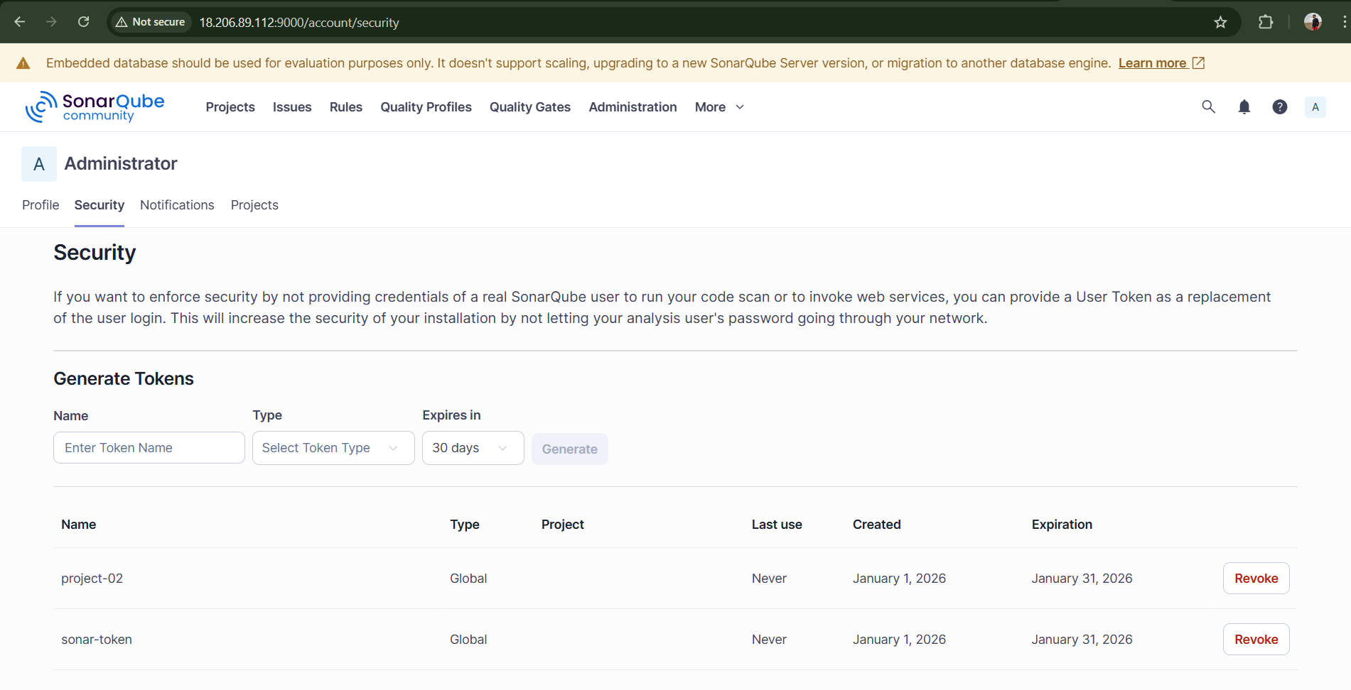
- In Jenkins:
  - Install SonarQube Scanner Plugin

  - Configure SonarQube server details
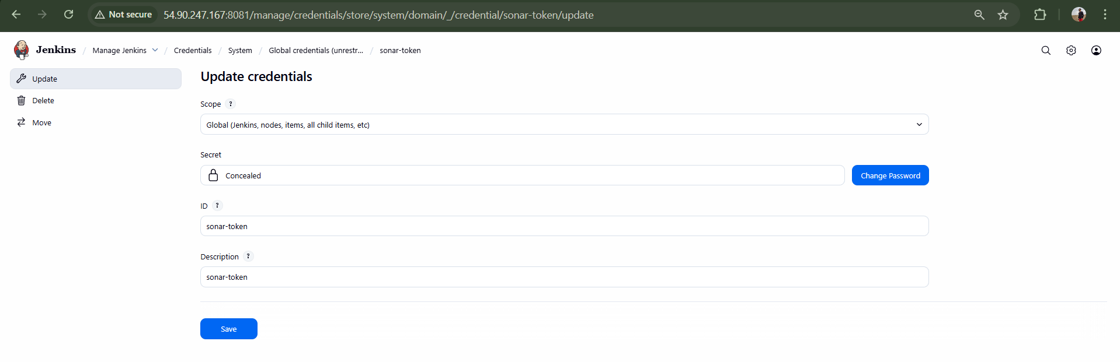
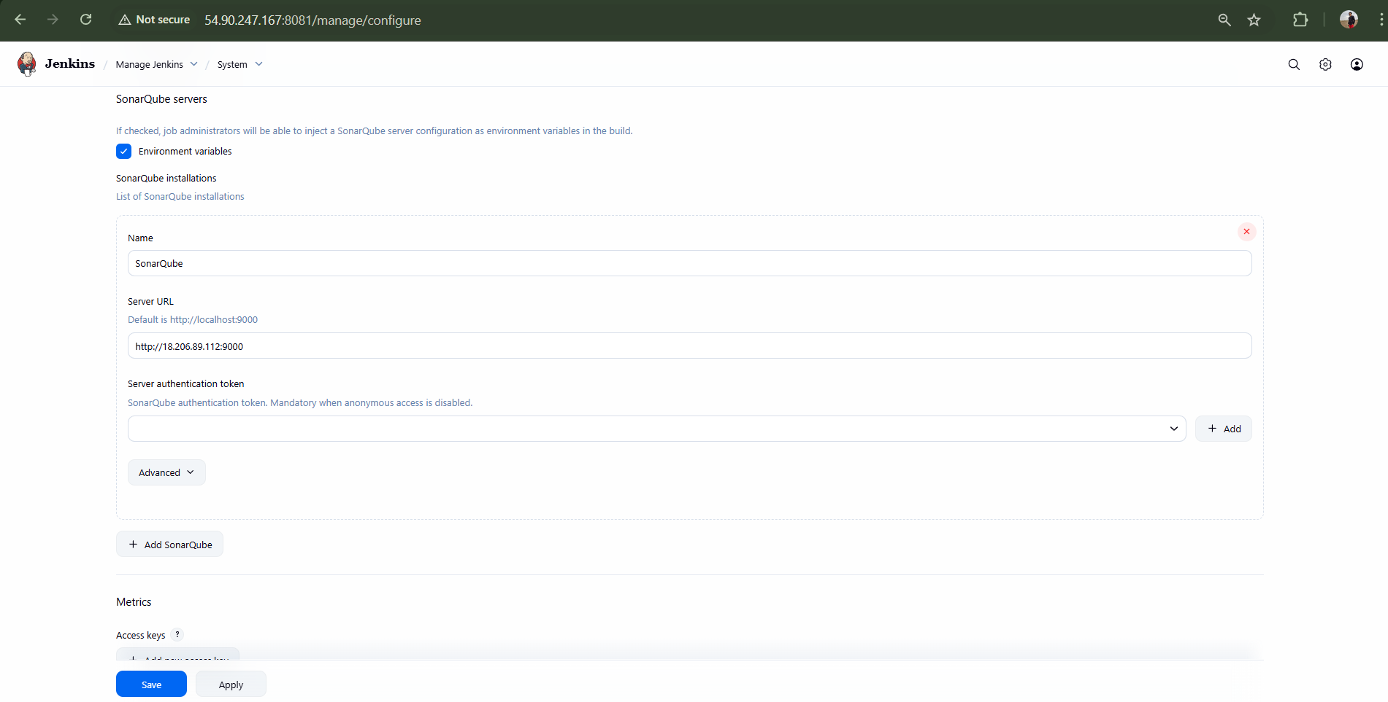
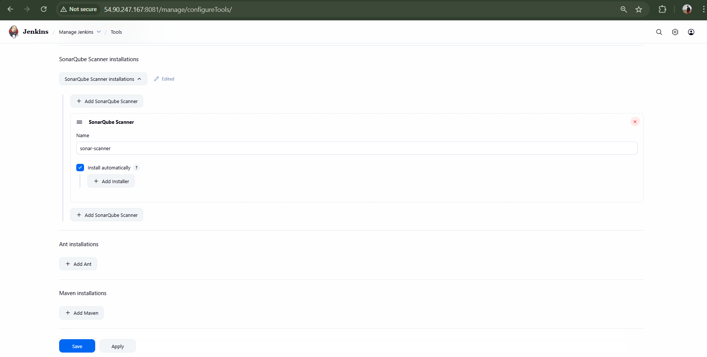

- Add SonarQube scanner build step and execute build.
Result: Code is successfully scanned and pushed to SonarQube dashboard.
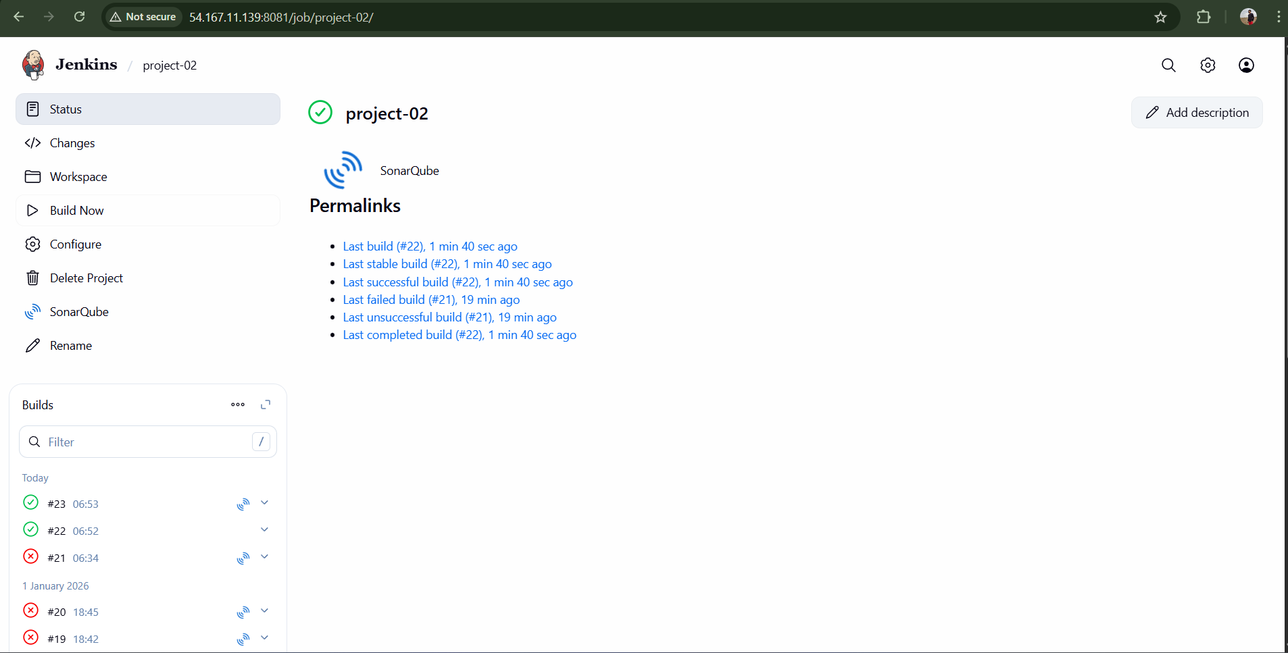
Validation : After adding sonar analysis to the projet-02 build then we can see that sonarqube is checking the code quality that we can see below
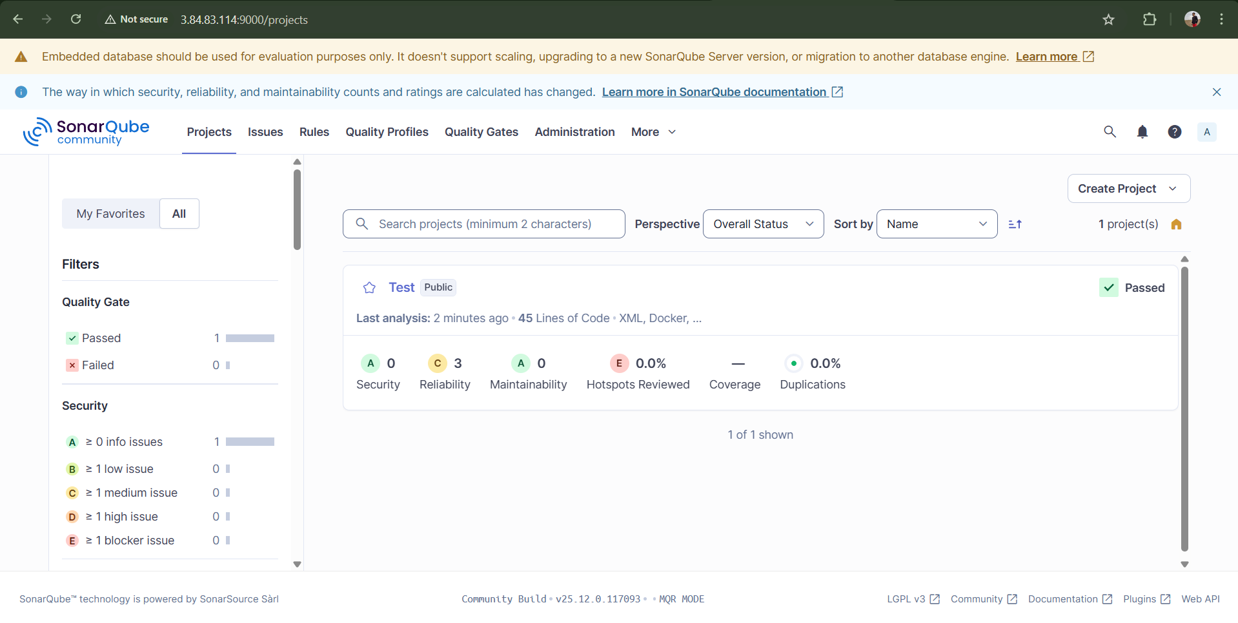

Stage 3: Slack Integration
- Install Slack Plugin in Jenkins.



- In Slack:
  - Add Jenkins App




  - Generate Slack token



- Configure Slack under Jenkins system settings.


- Add Slack notification in Jenkins job.
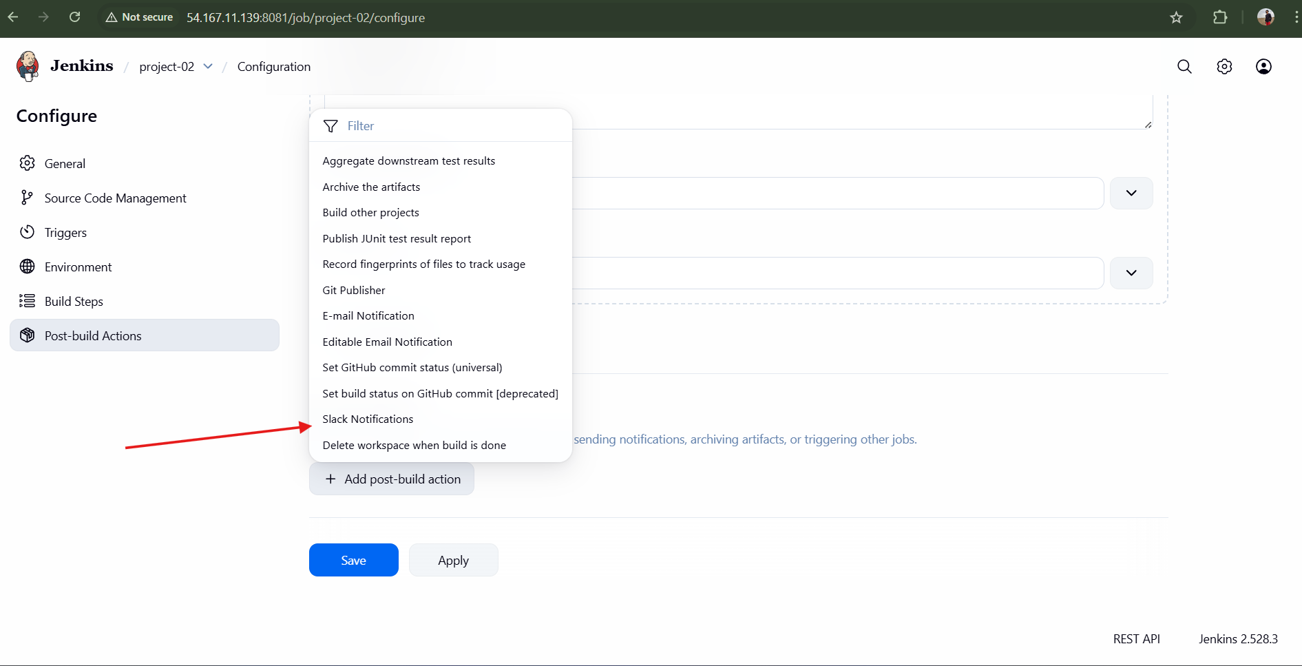
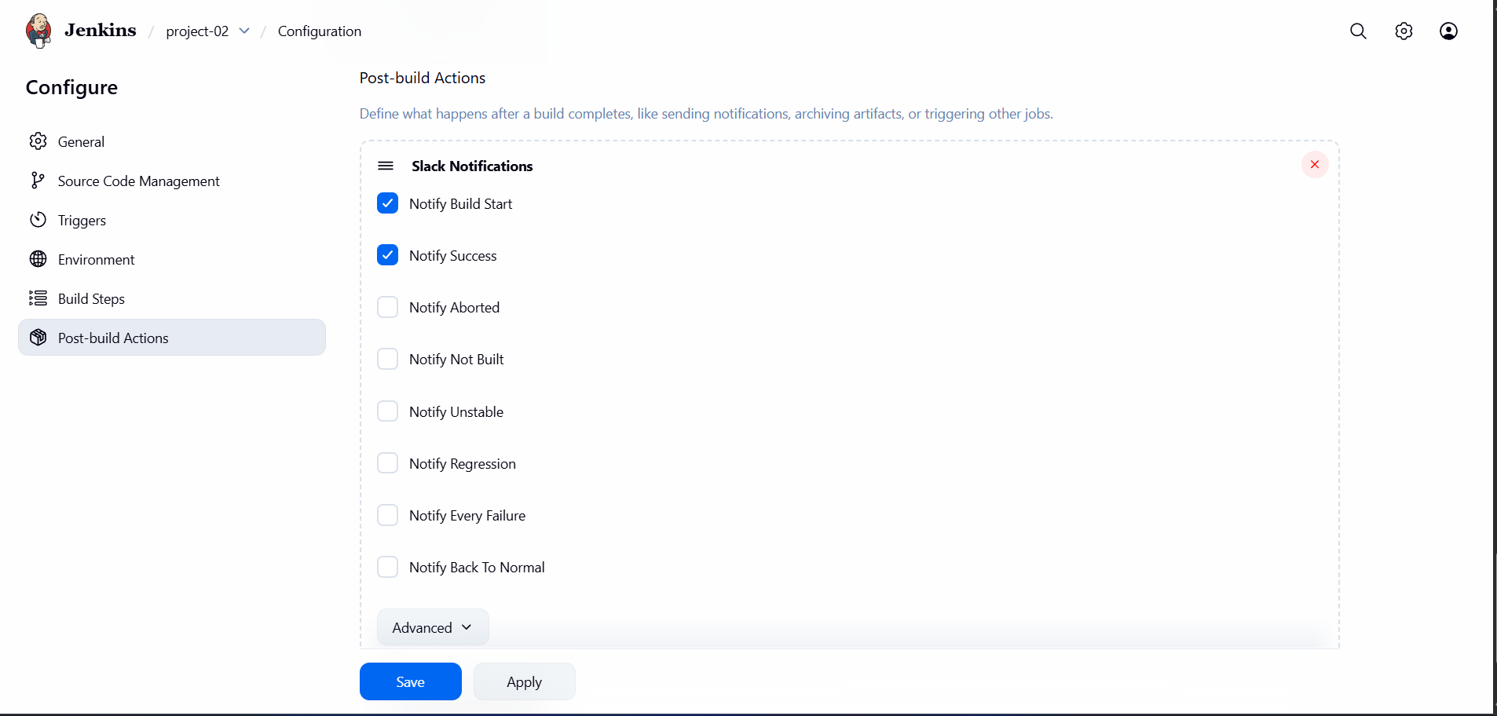
- Run Jenkins build.
Result: Slack receives build and code quality notifications.
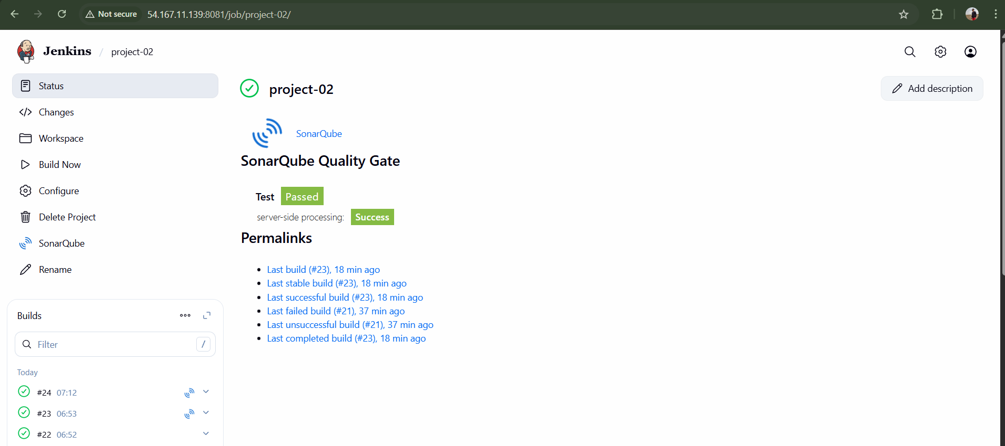
Validation : Received Slack-Notification of SonarQube buid in slack
#jenkins integration channel
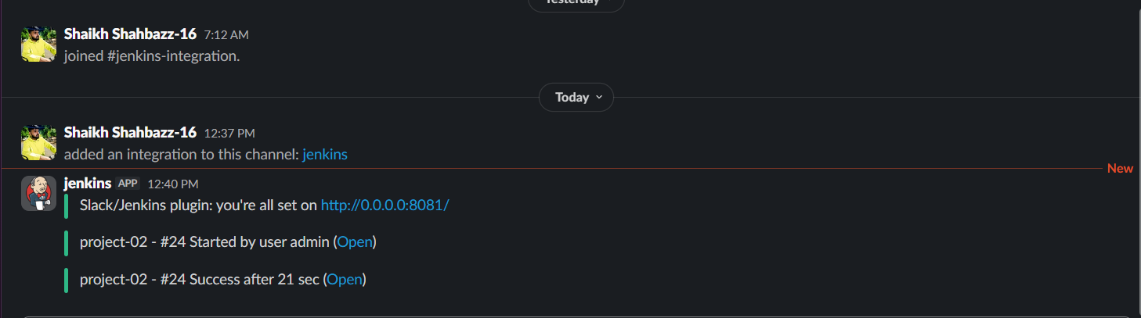
Conclusion
Successfully implemented a Jenkins CI job using Docker-based SonarQube for code quality analysis and Slack for real-time notifications.

